Useful formulas:
density = mass / volume
acceleration = (final velocity - initial velocity) / time
speed = distance / time
resultant force = mass * acceleration
weight = mass * gravitational constant
moment = force * perpendicular distance
pressure = force / area

Measurement | Unit | Symbol
Length | Meter | M
Mass | Kilogram | Kg
Time | Second | S
1. Fill in the table

2. Convert the following number to scientific notations
- 1 500 m
1.5 * 10^3 m

- 1 500 000 m
1.5 * 10^6 m
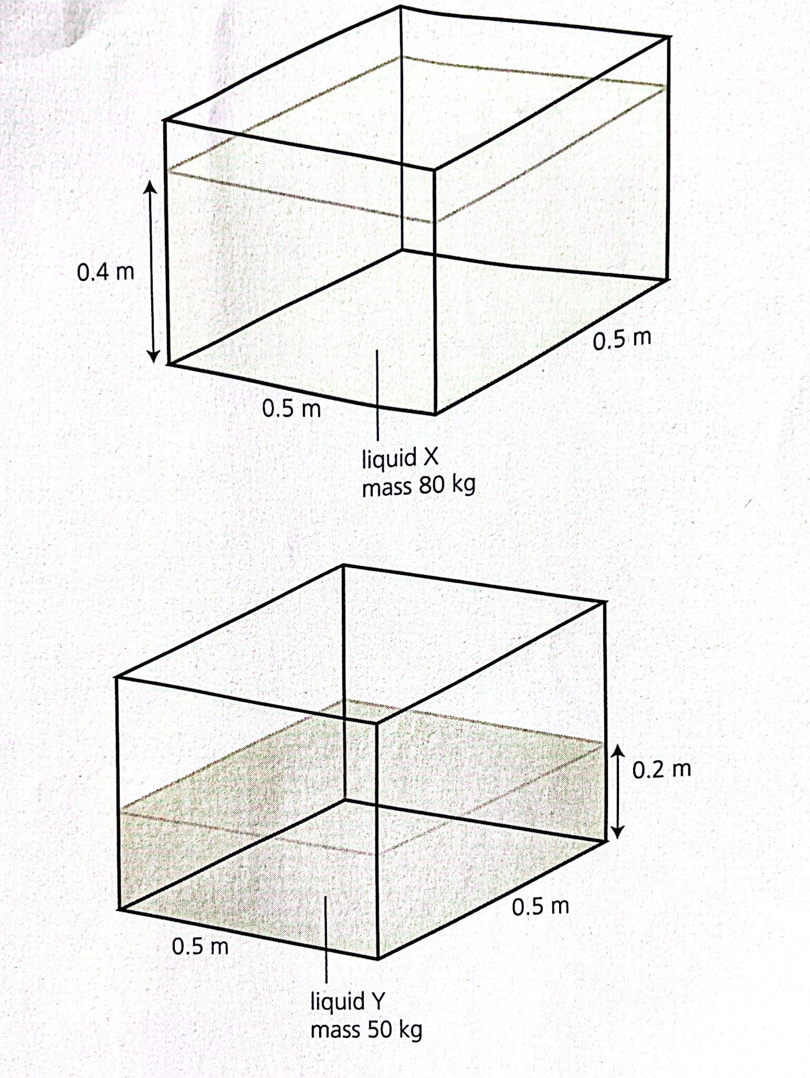
- 0.15 m
1.5 * 10^-1 m

- 0.015 m
1.5 * 10^-3 m

3. In the diagram, the tanks contain two different liquids, X and Y.
- What is the volume of each liquid in m^3?
Volume of liquid X = 0.5 m * 0.5 m * 0.4 m = 0.1 m^3
Volume of liquid Y = 0.5 m * 0.5 m * 0.2 m = 0.05 m^3

b. What is the density of liquid X?
Density of liquid X = 80 kg / 0.1 m^3 = 800 kg/m^3

c. What is the density of liquid Y?
Density of liquid Y = 50 kg / 0.05 m^3 = 1000 kg/m^3

4. A car travels at a steady speed of 20 m/s, Calculate the distance travelled in 5 s.
Distance = speed * time = 20 m/s * 5 s = 100 m

5. A car of mass 800 kg is propelled by a force of 3200 N. The total drag force of the car is 2000 N.
- What is the resultant force on the car at this instant?
Resultant force = 3200 N - 2000 N = 1200 N (forward)

b. Calculate the initial acceleration of the car.
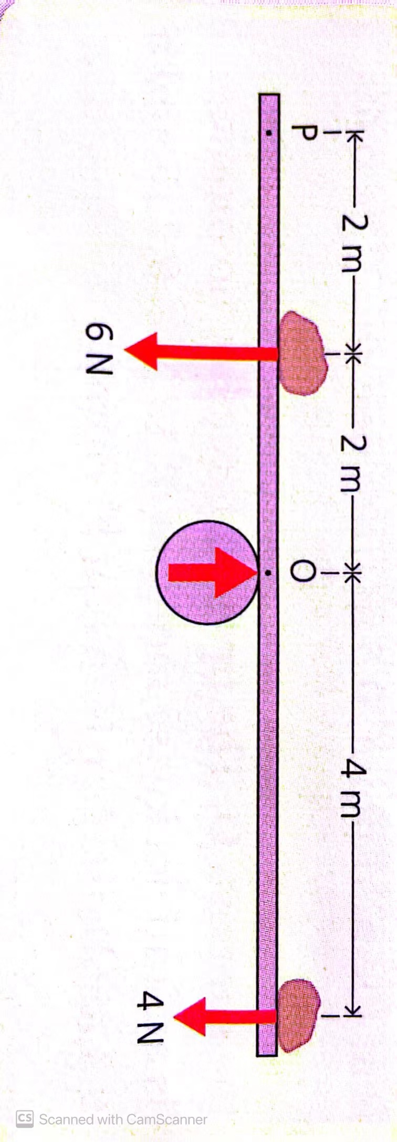
Acceleration = force / mass = 1200 N / 800 kg = 1.5 m/s^2

6. A satellite is in a circular orbit around the Earth. What supplies the centripetal force for the satellite?
Gravity

7. Below, Someone is trying to balance a plank with stones. The plank has negligible weight.
- Calculate the moment of the 4 N force about O.
Moment = 4 N * 4 m = 16 Nm (clockwise)

b. Calculate the moment of the 6 N force about O.
Moment = 6 N * 2 m = 12 Nm (anticlockwise)

c. Will the plank balance? If not, which way will it tip?
No, because the clockwise moment is larger than the anticlockwise moment.

d. What extra force is needed at point P to balance the plant?
Difference in moment = clockwise moment - anticlockwise moment = 16 Nm - 12 Nm = 4 Nm (clockwise)
Force = moment / distance = 4 Nm / 4 m = 1 N

e. In which direction must the force at P act?
Downward

8. What force is produced if :
- A pressure of 1000 Pa acts on an area of 0.2 m^2?
Force = pressure * area = 1000 Pa * 0.2 m^2 = 200 N

b. A pressure of 2 kPa acts on an area of 0.2 m^2?
Force = pressure * area = 2000 Pa * 0.2 m^2 = 400 N

