Homework Day 2 (Engineering, Physics, Math)
Engineering:
Day 2 HW Name: Date:
Ohm’s Law
1. An alarm clock draws 0.7 A of current when connected to a 120 volt circuit. Calculate its
resistance.
V=
I=
R=
2. A Walkman uses four standard 1.5 V batteries. How much resistance is in the circuit if it uses a current of 0.02A?
V=
I=
R=
3. How much voltage would be necessary to generate 20 amps of current in a circuit that has 5.5
ohms of resistance?
V=
I =
R =
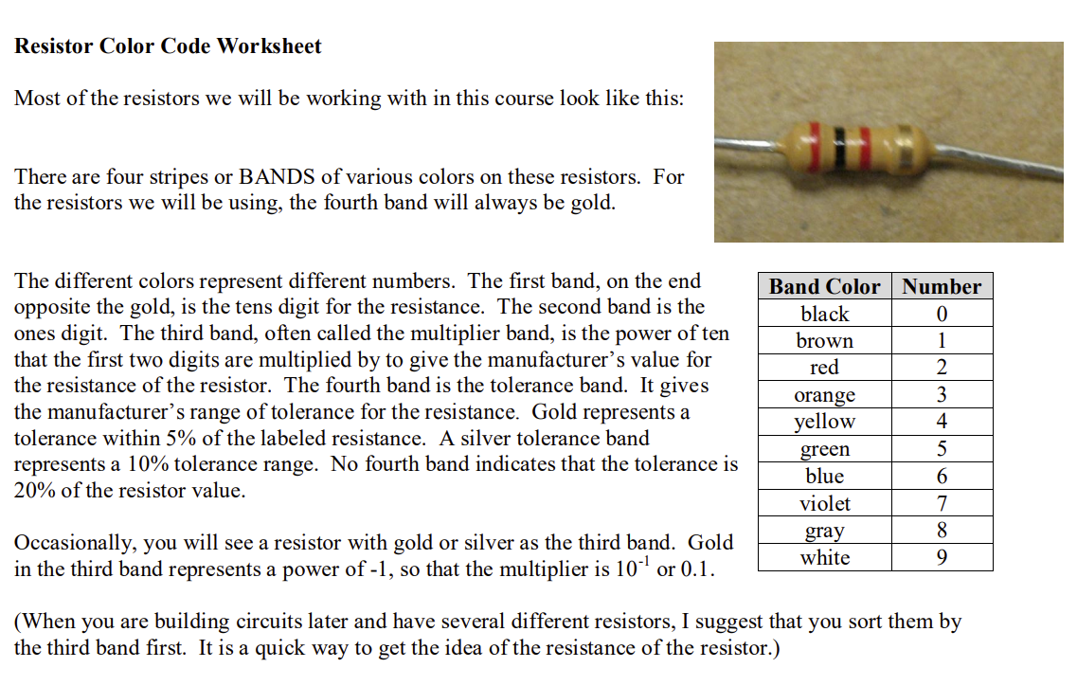
Write out the resistance and tolerance:





Physics
- A car travels at a steady speed of 20 m/s. Calculate the distance travelled in 5 s.

2. An aircraft on its take-off run has a steady acceleration of 3 m/s^2.
- What velocity does the aircraft gain in 4 s?

b. If the aircraft passes one post on the runway at a velocity of 20 m/s, what is its velocity 8 s later?

3. A truck travelling at 25 m/s puts its brakes on for 4 s. This produces a retardation of 2 m/s^2. What does the truck’s velocity drop to?

4. What is the SI unit of force?

5. A car has a mass of 800 kg. Its engine produces a force of 1500 N to push the car forward, and the total frictional force is 500 N backward.
- What is the resultant force of the car?

b. What is the car’s acceleration?

6. A car has a mass of 800 kg. Its driving force is 2000 N forward and it is travelling at a constant speed. What is the size of the total drag force backward?

Math
Think about the following questions before class


