Day 3 HW
Engineering
Watt’s Law Worksheet
Name:
Date:
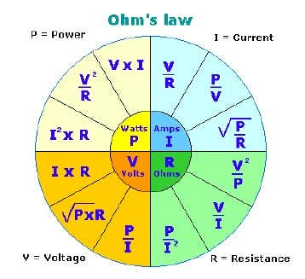
- Derive the following equations using Ohm’s and Watt’s laws:
Current as a function of Power and Voltage

Current as a function of Power and Resistance

Resistance as a function of Power Voltage

Resistance as a function of Power and Current

Voltage as a function of Power and Current

Voltage as a function of Power and Resistance
- The heating element on an electric stove dissipates 600 W of power when connected to a 120Vsource. What is the electrical resistance of the heating element?

- An electric motor draws 150 amps of current while operating at 240 volts. What is the power rating of the motor?

Physic
- A girl wearing a parachute jumps from a helicopter. She does not open the parachute straight away. The table shows her speed during the 9 second after she jumps.
- Complete the table by writing down the speed at 2 seconds.

b. How many seconds after she jumped did the girl open her parachute? How do the results show this?

c. i. What force pulls the girl down?

ii. What force acts upward?

iii. Which of these forces is larger:
at 3 seconds?
Time in seconds | 0 | 1 | 2 | 3 | 4 | 5 | 6 | 7 | 8 | 9
Speed in m/s | 0 | 10 |  | 30 | 40 | 25 | 17 | 12 | 10 | 10

at 6 seconds?

at 9 seconds?

d. What will happen if the girl is still falling after 9 seconds.

2. Assume someone is swinging a ball round on the end of a piece of string.
- What name is given to the force needed to make the ball move in a circle?

b. What will happen if the string breaks at a point?

c. Planets move around the Sun in approximately circular orbits. What provides the force necessary for the orbit?

3. Write down whether each of the following is an example of static friction or dynamic friction.
- The soles of your shoes gripping the ground when you are standing on a slope.

b. A crate being dragged across the ground.

4. Comparing the top and bottom of a surfboard:
- On which surface does the friction need to be high? Explain why.

b. On which surface does the friction need to be low? Explain why.

5. Assume that g = 10 m/s^2 and that there is no air resistance.
- A stone is dropped from rest. What is its speed after 2s?

b. A stone is thrown downwards at 20 m/s. What is its speed after 2s?

c. A stone is thrown upwards at 20 m/s. What is its speed after 5s?

Math
Review Session II PPT

